**EcolibriumReef - Arduino**

This is an aquarium controller based on Arduino. Its components are described below.

1. Arduino Nano or Arduino Nano compatible, the brain of the system.

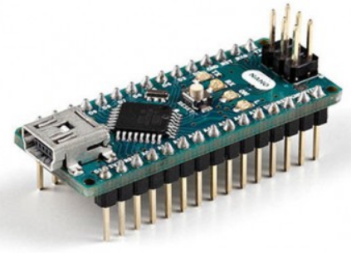

2. 4-channel relays. I use two to control 2 lights, 2 fans, 4 solenoid valves.

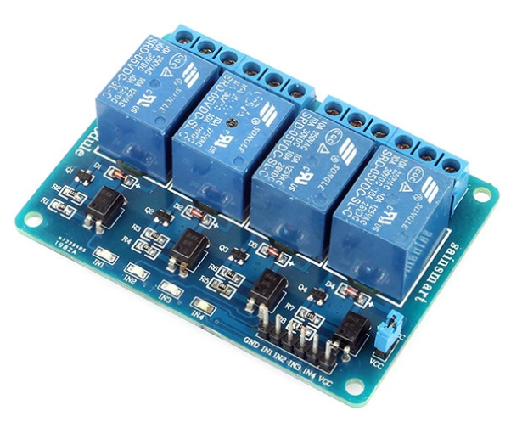

3. Wireless Bluetooth Serial HC-05 (make sure it is not HC-06) for communication with Android.

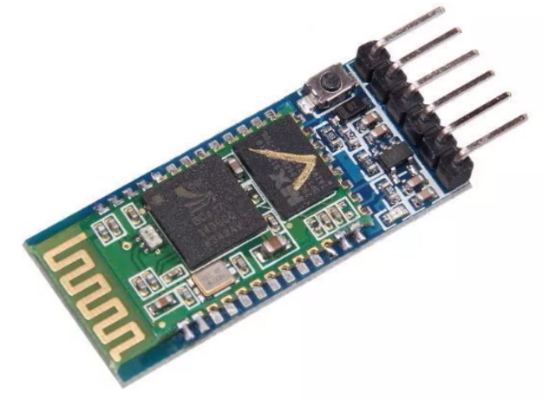

4. Temperature sensor DS18B20 (corrosion resistant) for measuring water temp. Multiple sensors (each has a unique address) can be connected to one Arduino connection.

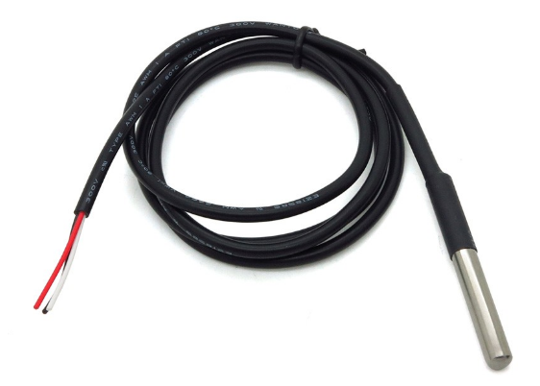

5. Real time clock DS3231. This is accurate within 2 minutes a year and has a backup battery.

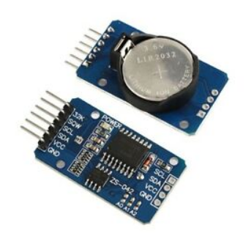

6. LCD 20x04/I2C display

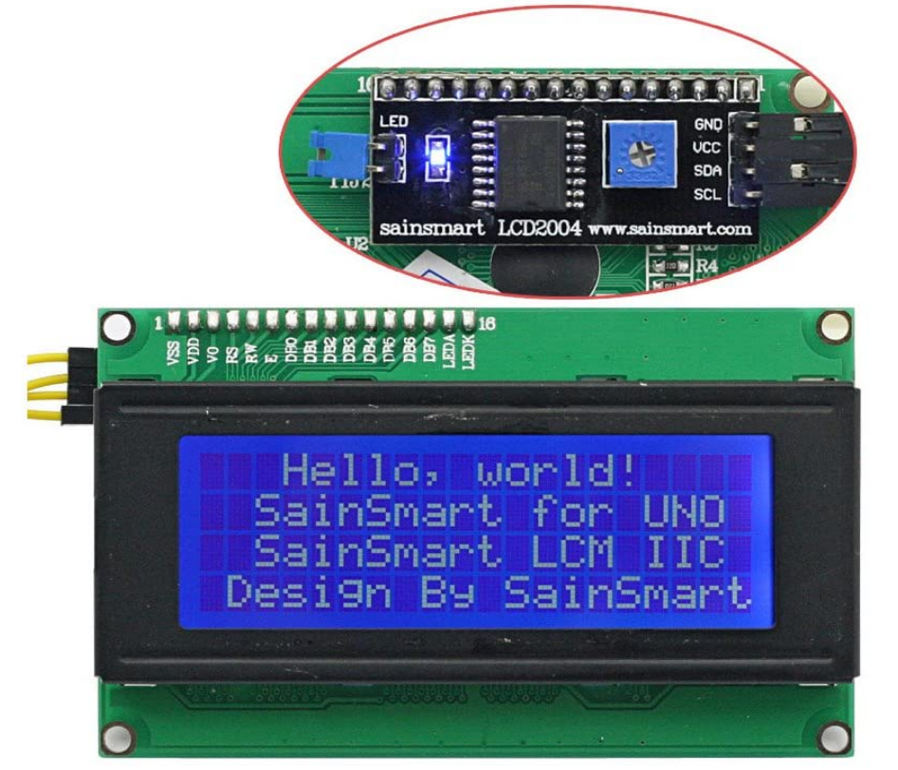

7. Float switch (corrosion resistant) to detect water level

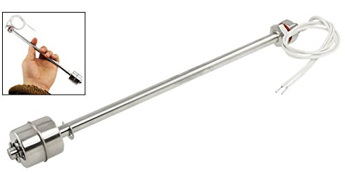

8. Temperature and humidity sensor DHT22 to measure air temp

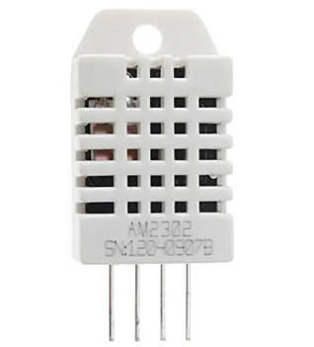

9. Momentary button (Push & Hold – ON, Release – OFF) to reset the system when necessary (check if the project box you use has a button)

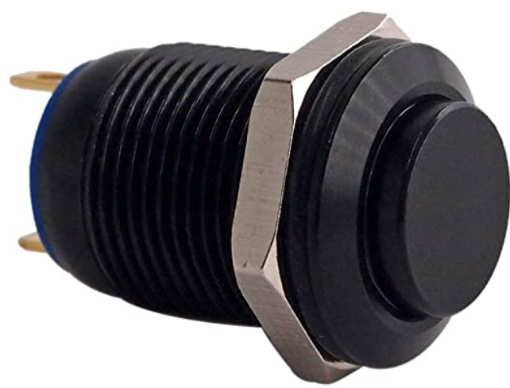

10. Stainless steel solenoids valves from autotopoff.com (must have at least two)

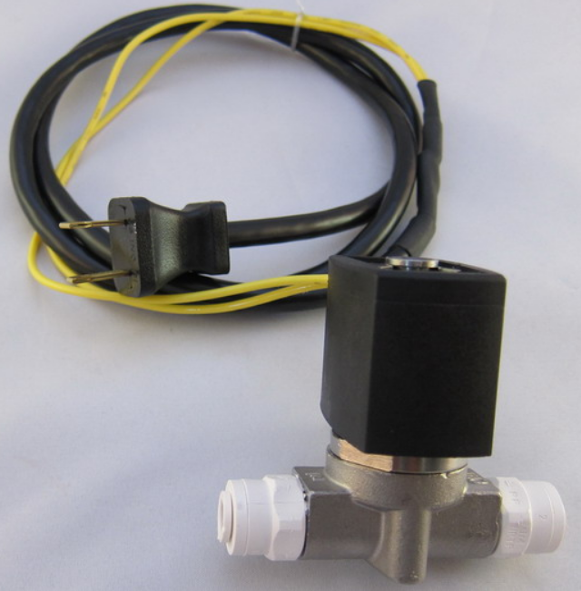 or 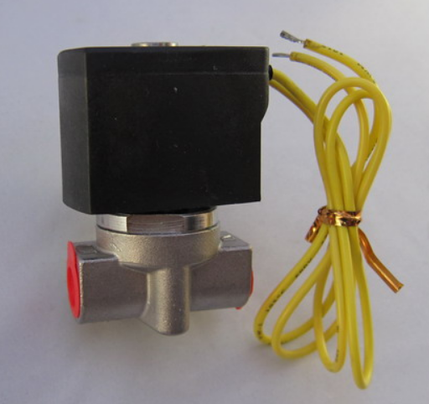

11. Cooling fans

There are many out there to chose from or you can harvest one from an old desktop computer. If you buy one, check air flow (CFM) and noise level (dB).

12. Project box

This old Motorola modem box 6" x 6" x 2" can house all electronics. You can use an old cable box, a dead external hard drive. When you gut out these boxes, there are components you don't want to remove such as a LED or a button which might be useful for this project.

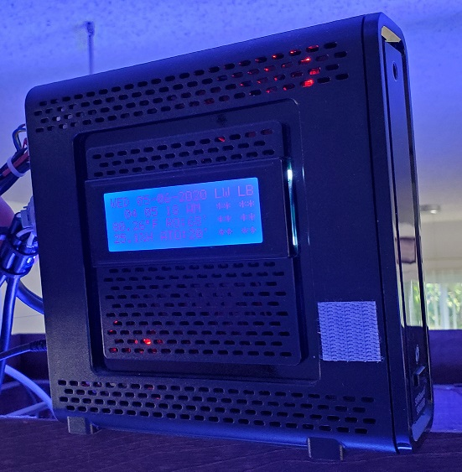

13. Solenoids housing

This is a DIY RO/DI that connects to the auto top-off and also drinking water.

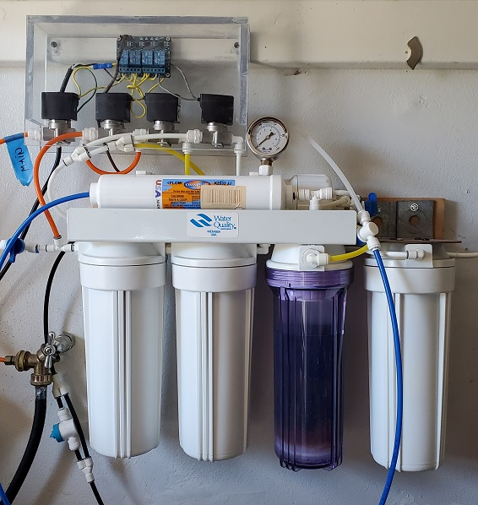

14. Power supplies:

5VDC, 2A for the Arduino Nano and all electronic components.

12VDC for the fans.

120VAC for the solenoids.

15. Bread board

A half size breadboard should be good enough. Most components plug right in to the bread board and connected by jumper. Once everything is tested, you can glue/fasten them down.

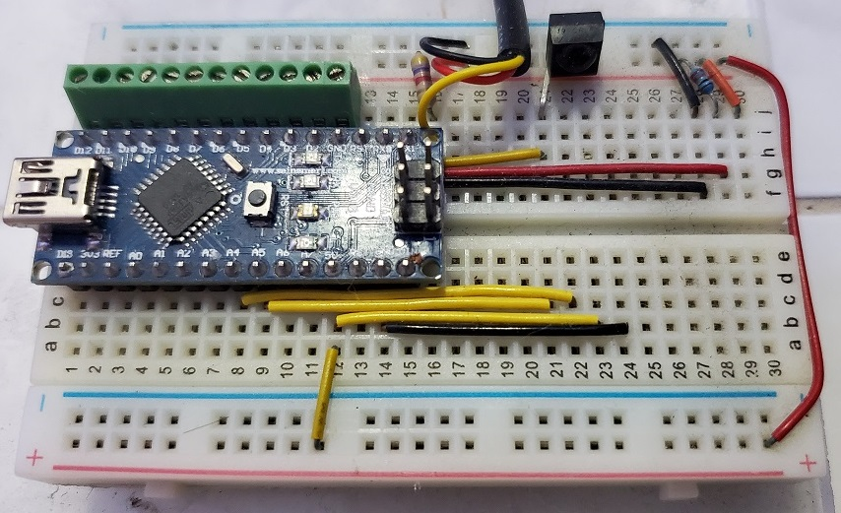

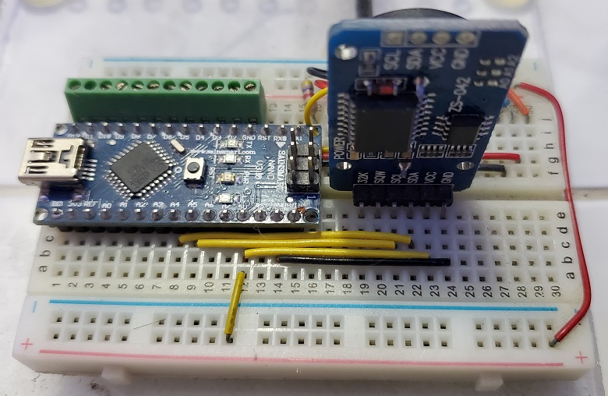

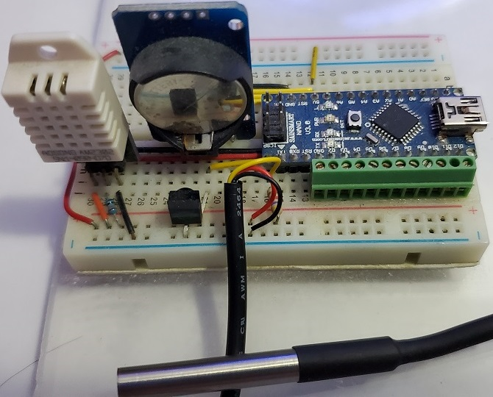

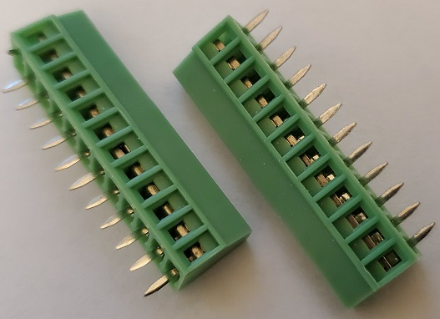

I use these screw terminals, which can plug right in to the breadboard, to connect the relays.

